Kingdom of Saudi Arabia
Ministry of Education
Project Title : Kernal distribution

Table of contents

- Introduction ………………………………………………………….. { 3 }

- What does the system do…………………………………………….. { 3 }
- Structured Filesystem
- Welcome Message
- Custom Shell Prompt
- Basic Utilities
- Successful Booting
- System Automation

- Instructions…………………………………………………………. { 4,5 & 6 }

- How it works………………………………………………………. { 6 & 7 & 8}

- Conclusion……………………………………………………………… { 8 }

- References………………………………………………………………. { 9 }

- Introduction:

- The purpose of this project is to construct an entire Linux distribution from scratch for learning basic OS principles and customization techniques. The system executes basic utilities after booting while maintaining its own customized filesystem patterns. Our system includes three custom elements: a welcome message, a modified shell prompt as well as automated testing features. The system construction demanded utilization of BusyBox, Linux kernel, QEMU alongside shell scripting and their corresponding tools.

- What does the system do :

  - The development of our basic Linux operating system included essential features which allowed our team to understand fundamental OS concepts

- Structured Filesystem:
We organized our basic system directory structure identically to Linux systems with core folders /bin, /etc, /home, /proc along with /sys
- Welcome Message:
After system initialization a user-specific welcome notice appears on the display. The operating system displays "Welcome to MyOS!" to establish a personalized touch.
- Custom Shell Prompt:
The default shell prompt of MyOS (~) > underwent a change where blue color was applied with automatic updating according to the current directory.
- Basic Utilities:
As a result of including BusyBox our system has access to essential commands such as ls, cd, vi and mkdir which allow smooth file movement and creation operations.
- Successful Booting:
The system successfully starts and displays the Linux kernel followed by a working command-line interface that operates without errors.
- System Automation:
Creating a shell alias named runos allows automated startup of QEMU testing with precise configurations thus reducing manual input for command execution.

- Instructions :

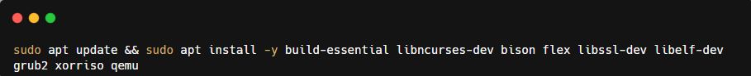
- Install Essentials on Ubuntu VM

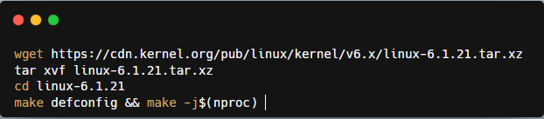
- Build the Linux Kernel

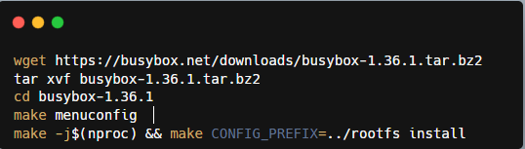
- Compile BusyBox (Core Utilities)

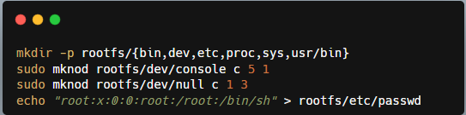
- Creating Minimal Filesystem

- Customize Startup :

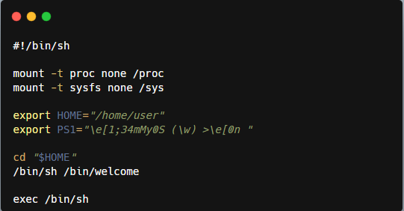
  - Inside ~/rootfs/init:

- Automate the ISO Building Process :
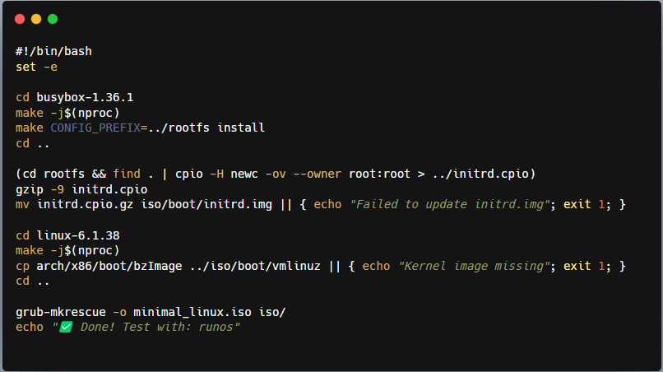
- A build script (build.sh) has been created to perform automated ISO generation:

- Create an Alias for QEMU Testing :

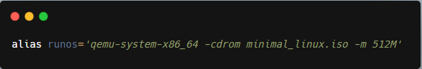
- We made an alias named runos within my .bashrc file to simplify testing.

- How it works :

- Install VMware

- Download Project file

- Extract the WinRAR file

- Open the file in VMware
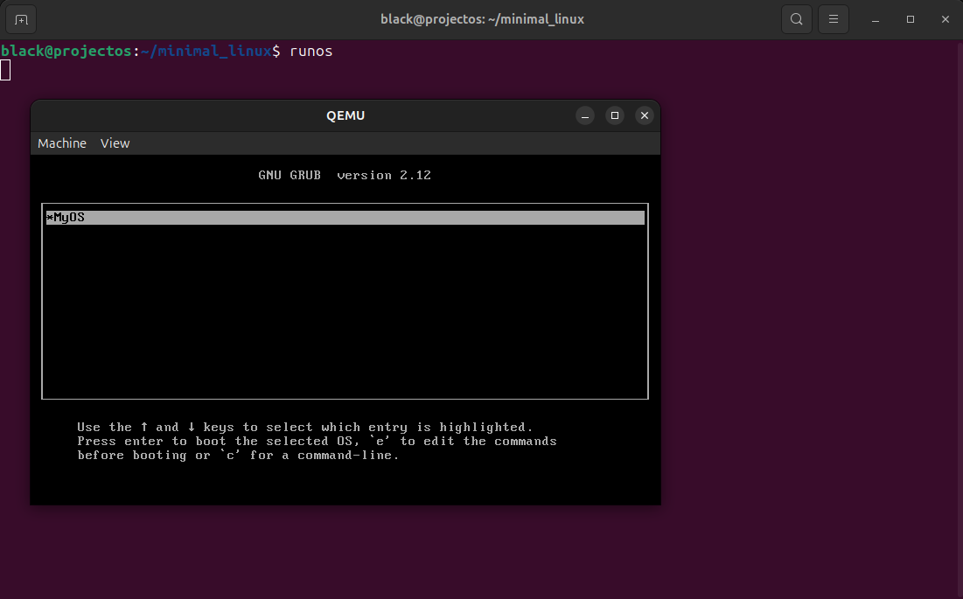
- Booting The MiniOS :

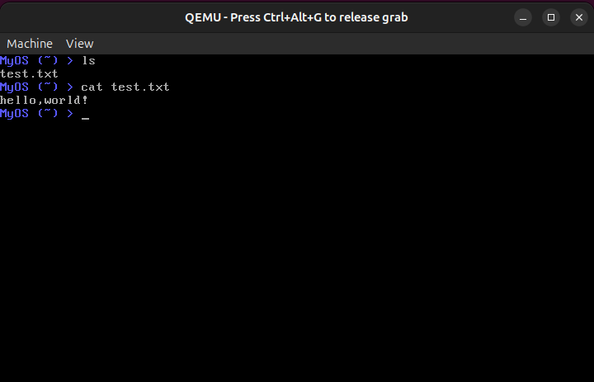
- Demonstrating a basic utility :

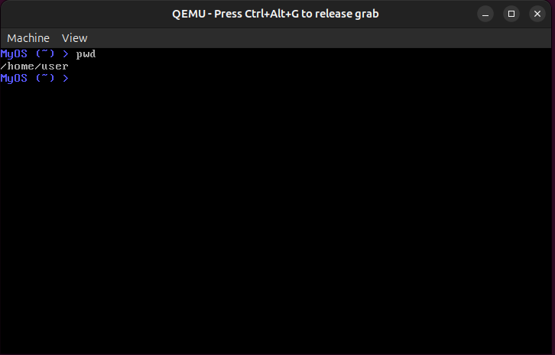
- Minimal root Filesystem structure :

- Showtime using custom system call :
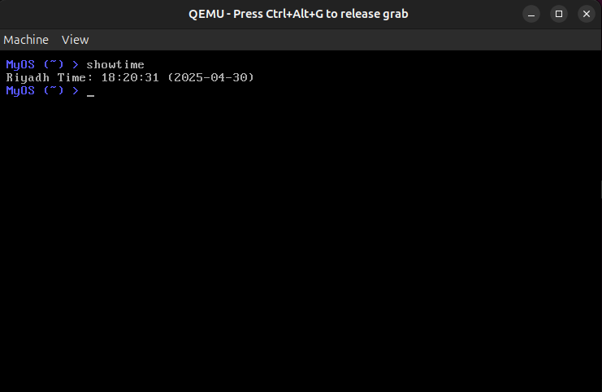

- Conclusion :

The project involved building a basic Linux operating system from original components to understand fundamental system elements. Building a custom kernel with BusyBox included for ls and vi utilities and designing a specific filesystem structure enabled us to develop a bootable OS system featuring customized messages and a blue shell interface (MyOS (~) >). Efforts in this research produced a working minimalistic system which links theoretical concepts with practical hands-on systems programming skills.

- References lists :

- https://youtu.be/fDaSSArmRjk?si=NJCFKyCQg2sZ3af5
- https://youtu.be/QlzoegSuIzg?si=wKete8itclQR4YlL
- https://www.linuxfromscratch.org/lfs/view/stable/chapter01/how.html

